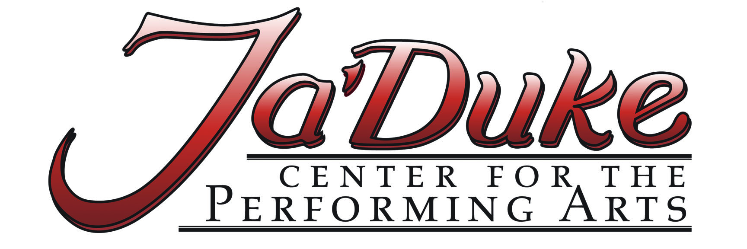

YANKEE CANDLE
Elf Information

Saturday, November 24th – 8:30am-10:00am – Santa’s Arrival
Meet at the candy store side of Yankee Candle (opposite Chandler’s) at 8:30am dressed and ready in elf costume. Make sure to dress warm, as we will be outside for the show. Students will be done at 10:00am. Be prepared to sing all songs on practice website.

*Go to www.jadukecenter.com
*Click on “Santa’s Arrival Practice Songs” at the top

Saturday, December 1st – 9:30am-10:00am – Santa’s Parade
Meet at the candy side of Yankee Candle (opposite Chandler’s) at 9:30am dressed and ready in elf costume. Make sure to dress warm, as we will be outside for the parade. Students will be done at 10:00am. Be prepared to sing and dance Santa Clause is Coming to Town from the practice website (last song listed).

Performers do not have to attend both events to participate. We are happy to have as many elves as we can for both events. Questions?? Call 863-0001 or e-mail jcpa@jaduke.com

